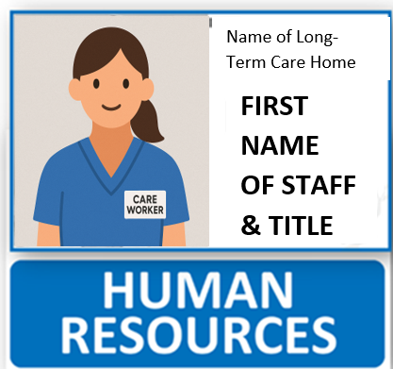
Administration | Management and office support staff. Plan, organize, direct and control the organization's services and operations.
Building Services | Building maintenance workers.
Care Aide  (CA) | Provides activities of daily living and personal care such as bathing, grooming, dressing, portering, assisting with meals and oral hygiene based on the residents’ care plans.
Chaplain | Responsible for providing spiritual care for residents and families. Spiritual care is the attention to the non-physical needs of an individual, which includes finding meaning and purpose in one’s life, addressing emotional distress and connecting to the transcendent. Assesses spiritual distress, facilitates prayer and ritual and identifies avenues of spiritual engagement to improve quality of life.
Clinical Nurse Leader  (CNL) | A senior role within a nursing team that oversees the work of an entire clinical nursing team or unit.
Companion | The family hired a residential support.
Dietitian  (DT) | Individualize nutrition care plans in consideration of residents’ disease states, preferences and health goals.
Director of Care  (DOC) | Supervises and observes direct resident care within LB and serves as the primary means of communication to the Executive Director regarding all aspects of resident care and services in the home.
Finance | Control the income and expenditure in addition to ensuring effective business running.
Food Services | Provide meals and snacks including menu planning, food purchasing, food storage and preparation, serving of meals and snacks, space and equipment requirements and sanitation.
Foundation | Charitable organization providing funds to LB. Founded and operating on a commitment to outstanding care for the valued seniors of our community. The Foundation enhances the well-being, care and happiness of all in care.
Health Care Support Workers (HCSW) | Entry level health care workers. They will go to school as part of the Health Careers Access Program (HCAP) and return to LB as Care Aides.
Housekeeping | Cleanliness, maintenance, aesthetic upkeep of rooms, public areas, back areas and surroundings.
Human Resources | Focused on the recruitment, training and retention of employees.
Infection Prevention and Control / Quality & Risk Management  (IPAC/QRM) | Refers to the management of evidence-based practices and procedures that, when applied consistently in health care settings, can prevent or reduce the risk of transmission of microorganisms to health care providers, clients, patients, residents and visitors. Risk management uses tools to assess risk and implement protocols.
Laundry | Responsible for providing an adequate, clean and constant supply of linen to all users.
Licensed Practical Nurse  (LPN) | A nurse who provides basic patient care. LPNs work under the supervision of registered nurses (RNs), doctors and other providers.
Reception | Answer phones, take messages and direct calls to the appropriate staff members or departments. Address and manage inquiries about the facility, residents’ status and general information.
Music Therapist (MT) | The goals that music therapists work on are based on five domains: social, emotional, cognitive, communicative and physical. Music therapists are a part of the interprofessional team. They conduct assessments, develop treatment plans, deliver therapy, and measure and document the residents’ level of engagement.
Recreation Therapy Assistant  (RTA) | Works under the direct supervision of a recreation therapist to deliver leisure-based interventions in both one-to-one and group formats. The recreation therapy assistant is essential in program implementation, observation and reporting.
Jewish Values & Traditions Coordinator | Develops, implements and evaluates recreation activities that promote Jewish heritage and meet residents' social, physical, intellectual and spiritual needs.
Recreation Therapist  (RT) | Provides therapeutic recreation interventions with specific clients and/or client groups. As a member of the interprofessional collaborative health care team, they conduct assessments, develop treatment plans, deliver therapy, measure and document the residents’ level of engagement.
Rehab Assistant (RA) | Engages residents in participating in individual/group rehab exercise as prescribed by therapists and assists therapists in daily operations: wheelchair maintenance, falls equipment, mobility aids and therapeutic surfaces.
Occupational Therapist  (OT) | Focuses on areas including maintaining participation in activities of daily living (ADL), seating, power wheelchair assessment and training, pressure injury prevention, swallowing, cognitive assessment and fall prevention.
Physical Therapist  (PT) | Promotes and maintains the level of function and mobility a resident has at the time of admission. Carries out assessments to maintain mobility, increase independence and ensure maximum quality of life, including catering rehab programs, providing access /repair to mobility aids and falls prevention.
Registered Nurse  (RN) | Provides extended care to residents living with disabilities or suffering from progressive or chronic illnesses. These specialized registered nurses often work with the elderly and others who need assistance with daily living.
Social Worker | Liaises with residents, families, the inter-professional team and community stakeholders during admissions, discharges and transfers. Collaborates with other members of the care team to provide person-centred, anti-oppressive and evidence-based care.
Visitation Assistant  (VA) | Opens the door, welcomes visitors, guides them through protocol and provides assistance/direction when needed.
Volunteer | Often focus on helping staff fulfill their needs and assisting residents with daily activities, which helps improve the residents’ overall health and well-being.

