Dear Resident and Family,

We would like to welcome you to Insert the Long-Term Care Home Name. We are excited for you to be a part of our resident and family community. Here at Insert the Long-Term Care Home Name, we pride ourselves on being a center of excellence for our residents, providing outstanding care consistent with our values that respects and supports quality of life. We recognize that the admission process can feel overwhelming, and we want to assure you that our team is here to support you through the journey.

We will provide you with various information throughout the admission process to help you prepare along the way. In this communication, we will include the following documents:
- a checklist of items to bring with you upon admission
- a staff directory with contact information
- a brochure from our family council
- an information sheet on the acquisition of resident belongings in the event of discharge or death

In an additional email, we will be sending you an electronic copy of our Residency Agreement and Funeral Arrangements Form.
Please monitor for an email from the following: Insert the email address.
Please check your junk folder if you have not received the email.
We require the Residency Agreement document to be electronically signed before your admission day.

Please see a screenshot of the email below. If you have any questions or concerns about the form, please reach out as soon as possible:

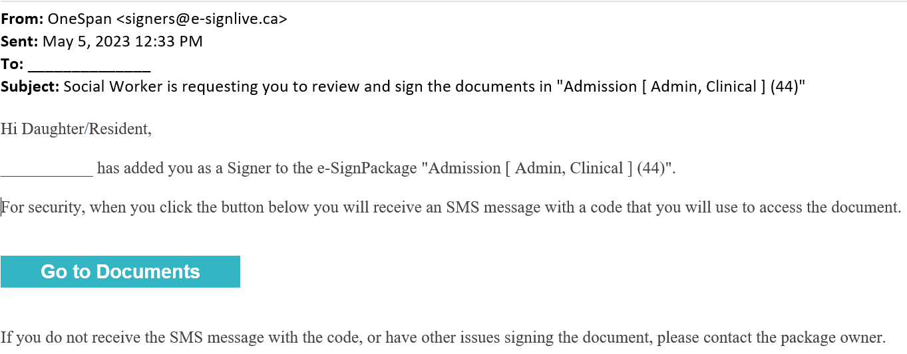

If you have any questions or concerns, please see the attached contact list to reach out to our care team.

Sincerely,
Long-Term Care Home Name Admissions Team

