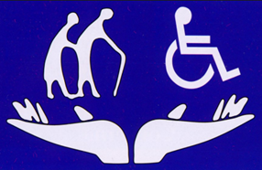

Family Council
Day/Month/Year
email address

Family Council is a self-led, self-determining group of families and friends of Insert Care Home Name residents. We advocate for continuous improvement in the quality of life of the residents by way of collaboration with senior leadership. We provide a support forum to share concerns, explore possible causes, and create “next steps”; we facilitate communication in a constructive manner for problem resolution; we solicit examples of what is working well for positive feedback, and we take part in various committees and initiatives at Insert Care Home Name.


Our Conversations:
- TOPIC 1
Notes
- TOPIC 2
Notes

- TOPIC 2
Date of next meeting:

Time meeting ended:

PLEASE join our meetings, volunteer on the Executive Council or simply send us an email to let us know about your experiences: Insert an email address

