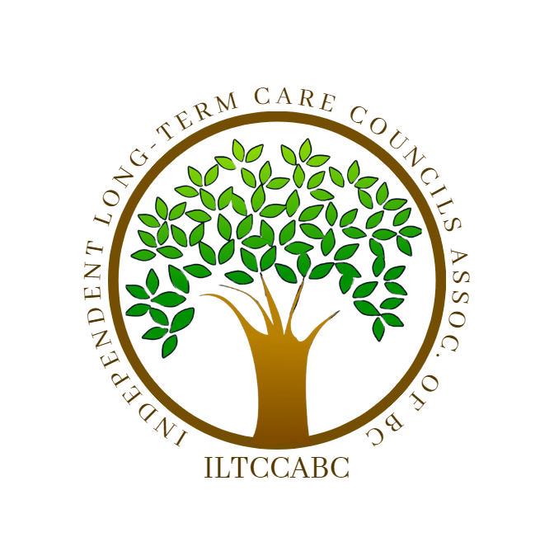

Concerns and Complaints

There are a few ways to report and resolve concerns and complaints about home and community care services.
Suggested levels of inquiry in order of action:
1. Direct to the person best suited to discuss the situation with
(Nurses station, Clinical Nurse Lead, Director of Care, etc.)
2. Care Home operator/CEO/Manager
4. Patient Care Quality Offices
Every health region in B.C. has a Patient Care Quality Office. If your care concern has not been addressed by working with your long-term care home, you are encouraged to contact the Patient Care Quality Office in your health region.
For information on how to contact the patient care quality office at
your health authority, see: Patient Care Quality Review Boards: Make a Complaint
5. Patient Care Quality Review Boards
If you are not satisfied with how your complaint has been handled by
the Patient Care Quality Office in your region, you can request a
review by an independent Patient Care Quality Review Board.
To learn more about the Patient Care Quality Review Board process, please visit: Patient Care Quality Review Boards: Request a Review

6. Community Care Licensing Offices
Community Care Licensing Offices are in every health region in B.C. Complaints concerning licensed community care facilities may be referred to the licensing office in your area.
For more on licensed community care facility complaints, and contact information for licensing offices in your area, please visit: Ministry of Health: Community Care Licensing Complaints

7. Office of the Seniors Advocate Information and Referral Line
The Seniors Advocate Information and the Referral Line allows seniors, their families, or other concerned individuals in their lives to report concerns about their care. The toll-free phone line is available Monday-Friday, from 8:30 a.m. to 4:30 p.m. by calling:
Office of the Seniors Advocate:
• 1-877-952-3181 outside Victoria, BC
• 250-952-3181 in Victoria, BC

8. Ombudsperson
If you believe a decision or response about home and community care services is unfair, unreasonable, or inconsistent with relevant policy, procedures, or legislation, you may wish to raise your concerns with the Office of the Ombudsperson. The Ombudsperson is an independent Officer of the B.C. Legislature who impartially investigates complaints from the public to ensure people are treated fairly in the delivery of government services.
For more information, visit their website www.bcombudsperson.ca or call 1-800-567-3247. Ombudsperson: How to Make a Complaint
9. Medical Health Officer
Medical Health Officers (MHOs) derive their powers and duties from the Public Health Act. They have legislated responsibilities under several Acts and regulations. They have the responsibility to comply with established professional standards in the quality of their work and are reviewed by the Chief Medical Health Officer or Provincial Health Officer.
- British Columbia Medical Health Officers (PDF, 186KB)

